**1 . Implementing the Singleton Pattern**

public class Logger {

    private static Logger instance;

    private Logger() {

        System.out.println("Logger instance created.");

    }

    public static Logger getInstance() {

        if (instance == null) {

            instance = new Logger();

        }

        return instance;

    }

    public void log(String message) {

        System.out.println("Log: " + message);

    }

}

public class Main {

    public static void main(String[] args) {

        Logger logger1 = Logger.getInstance();

        Logger logger2 = Logger.getInstance();

        logger1.log("First log message.");

        logger2.log("Second log message.");

        if (logger1 == logger2) {

            System.out.println("Both logger instances are the same (Singleton works).");

        } else {

            System.out.println("Logger instances are different (Singleton failed).");

        }

    }

}

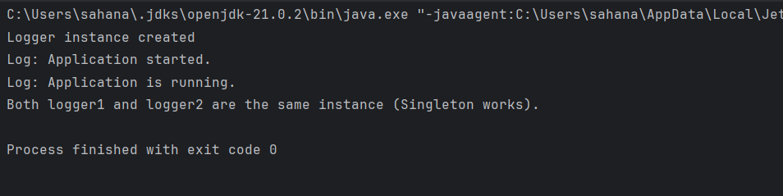

2 . **Implementing the Factory Method Pattern**

public class FactoryMethodPatternExample {  
  
 // Step 1: Document interface  
 interface Document {  
 void open();  
 }  
  
 // Step 2: Concrete Document classes  
 static class WordDocument implements Document {  
 public void open() {  
 System.*out*.println("Opening a Word document.");  
 }  
 }  
  
 static class PdfDocument implements Document {  
 public void open() {  
 System.*out*.println("Opening a PDF document.");  
 }  
 }  
  
 static class ExcelDocument implements Document {  
 public void open() {  
 System.*out*.println("Opening an Excel document.");  
 }  
 }  
  
 // Step 3: Abstract Factory  
 abstract static class DocumentFactory {  
 public abstract Document createDocument();  
 }  
  
 // Step 4: Concrete Factories  
 static class WordDocumentFactory extends DocumentFactory {  
 public Document createDocument() {  
 return new WordDocument();  
 }  
 }  
  
 static class PdfDocumentFactory extends DocumentFactory {  
 public Document createDocument() {  
 return new PdfDocument();  
 }  
 }  
  
 static class ExcelDocumentFactory extends DocumentFactory {  
 public Document createDocument() {  
 return new ExcelDocument();  
 }  
 }  
  
 // Step 5: Test class  
 public static void main(String[] args) {  
 DocumentFactory wordFactory = new WordDocumentFactory();  
 Document wordDoc = wordFactory.createDocument();  
 wordDoc.open();  
  
 DocumentFactory pdfFactory = new PdfDocumentFactory();  
 Document pdfDoc = pdfFactory.createDocument();  
 pdfDoc.open();  
  
 DocumentFactory excelFactory = new ExcelDocumentFactory();  
 Document excelDoc = excelFactory.createDocument();  
 excelDoc.open();  
 }  
}

